Technical Documentation- Create Superuser and Login to Admin Panel

Pre-steps (for Windows)

1. Get into Django
   1. Go to your portfolio directory in cmd prompt (in CS3300)
   2. Start Django Cmd: **djvenv\Scripts\activate**

Actual steps- to make a superuser

1. CMD: **python manage.py createsuperuser**
   1. Ensure the cmd is not **python3 manage.py createsuperuser** (you will get a false positive error)
2. Enter in username, email address, and password you want associated with the application
   1. EX: 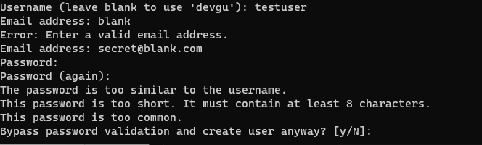
   2. You can put a fake address if you want
   3. Password can be short with an override of **y**
   4. This process can be repeated for multiple or incorrect attempts
   5. To change an existing password on a superuser **python manage.py changepassword <username>**
   6. **CTRL+ C** to cancel
3. **Login steps:**
   1. Run the server: **python manage.py runserver**
   2. Connect to: <http://127.0.0.1:8000/admin/>
   3. Use the login credentials you created
   4. 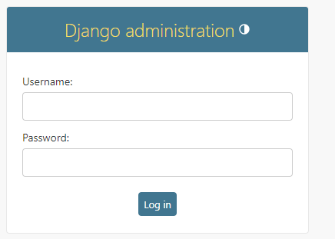
   5. Success: 